**SETTING UP THE APPLICATION ENVIRONMENT**

**IBM CLOUD CLI INSTALLATION**

|  |  |
| --- | --- |
| **DATE** | 27 October 2022 |
| **TEAM ID** | PNT2022TMID24193 |
| **PROJECT NAME** | Inventory Management System for Retailers |

**RUN THE FOLLOWING COMMAND AS ADMINISTRATOR IN POWERSHELL:**

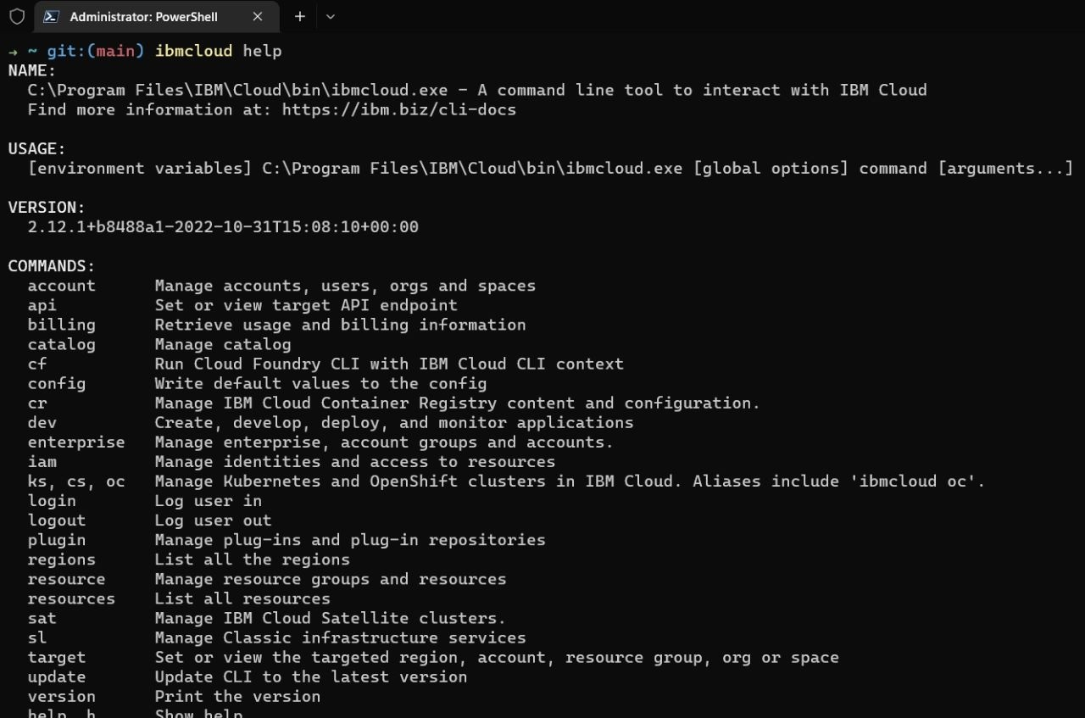Command :

iex(New-Object Net.WebClient).DownloadString(‘<https://clis.cloud.ibm.com/install/powershell>’)

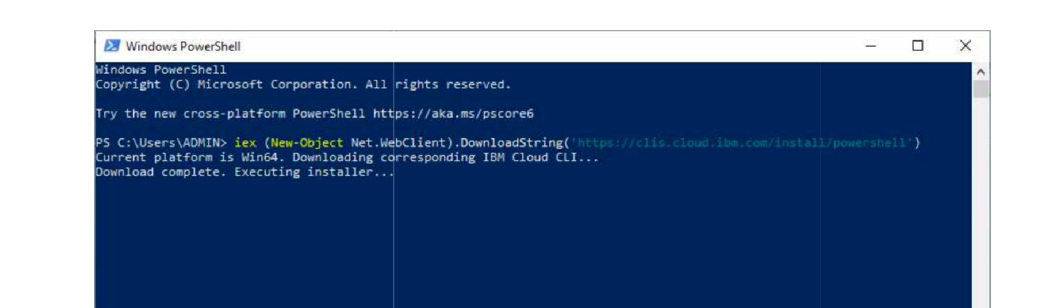

**CHECK IF IBM CLOUD CLI IS CORRECTLY INSTALLED:**

Command : ibmcloud help

**CONFIGURE OUR ENVIRONMENT:**

Command :

ibmcloud login

